GRTTS FIELD REPORT
WINTER OFFENSIVE
Wildlife Incidents & Anti-Poaching Operations, Late June – Early July 2026
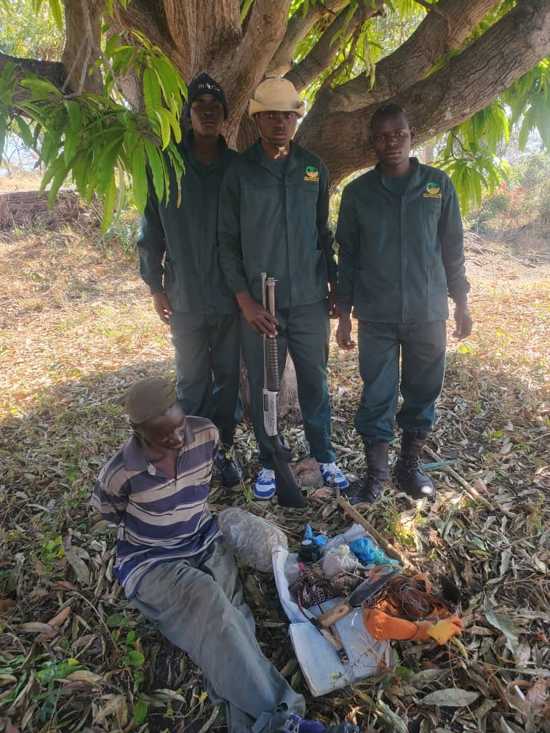
ELEPHANT HILLS • MAVHURADONHA WILDERNESS AREA • GWAYI PAINTED DOG CONSERVATION AREA • KARNABLOCK
Game Ranger and Tracker Training Specialist (GRTTS)

FEATURE

Winter Is Poaching Season
Winter in Zimbabwe brings more than dry bush and cold nights — it brings a predictable spike in poaching. Crops have been harvested. Tobacco farmers have sold their season's yield at market. And across the villages bordering community reserves, private conservancies, and protected wilderness areas, a lot of young men are left with idle hands and empty pockets. For many, subsistence poaching becomes the fallback.
The land itself works against wildlife at this time of year too. It's full moon season, the bush is dry, vegetation has thinned out, and visibility has opened up in areas that were once naturally screened by foliage. Ground that was difficult to move through even a few months ago is now easy to access — for poachers as much as for rangers. Anti-poaching units also stand guard against a related danger this season: wildfires deliberately set by poachers to drive game toward waiting snare lines.
“This is exactly the season when protected areas need to tighten up.”
It's why organizations like GRTTS (Game Ranger and Tracker Training Specialist) exist — deploying specially trained rangers into properties across Zimbabwe to get ahead of this seasonal rise before it costs conservancies their wildlife. The incidents in this report, from June into early July, reflect that work: arrests built on real intelligence, prolonged weeks of patrols, and rangers sitting on ambush for hours to bring poachers in rather than simply chasing them off. Several of these cases have already gone through the courts, with convicted poachers now serving time — a genuinely positive outcome for the conservancies involved.
What follows is a detailed, incident-by-incident account of that work: an accident on a reserve road, a hunting party that slipped away but paid a price for it, an arrest made mid-chase, and a snare-layer stopped before he could set his next line.
GRTTS is a privately owned wildlife protection service, and its rangers are available to any protected area or conservancy that needs reinforcement through this high-risk season — from now through to the start of the rains, when poaching pressure typically eases.

BY THE NUMBERS

The Reporting Period at a Glance
Five incidents. Four locations. One consistent pattern: poachers exploiting the dry season, and rangers meeting them with sustained, intelligence-led patrol work.
3  PEOPLE ARRESTED | 4  POACHING DOGS LOST BY SUSPECTS | 31+  SNARES REMOVED | 1  FIREARM ON APU STANDBY | 1  WILDLIFE ROAD INCIDENT

ELEPHANT HILLS

When the Road Becomes the Danger
Not every threat to wildlife comes from a snare or a hunting dog. On 4 July, rangers Tawanda Mhako and Purge S. Muleya responded to a report on the southern side of the Main Gate at Elephant Hills — a juvenile female impala struck by a vehicle.
The rangers were on scene within the hour, logging the incident at 16:24 and confirming the case had been handed to ZimParks for follow-up by 17:27.
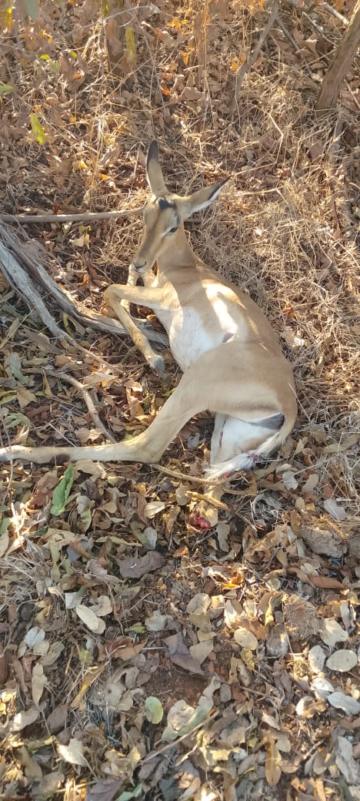  Juvenile female impala, struck by a vehicle near the Elephant Hills Main Gate. | It's a smaller story than an arrest, but it belongs in the record all the same. Roads through wildlife areas carry real risk for animals moving along the same routes as vehicle traffic, especially at dawn, dusk, and night when visibility drops for drivers and wildlife alike.  Quick, accurate reporting on incidents like this helps build a clearer picture of where and when these collisions happen — the first step toward preventing the next one.
Rangers on duty: Tawanda Mhako, Purge S. Muleya

MAVHURADONHA WILDERNESS AREA, GURUVE

They Saw the Ambush First
Not every encounter ends in an arrest. Sometimes the best outcome available is denying poachers their equipment and their dogs — and making sure they leave with nothing but the clothes on their backs.
That's what happened in the bush between Old Support Base and Lions Mountain. Rangers had already logged a heavy toll from this hunting party — three impala killed by a pack of dogs before the team ever closed the distance. As rangers moved to intercept, the dogs, running ahead of their owners, picked up on the ambush position before rangers could spring it. The four poachers, working from higher ground on the mountain, saw the disturbance and bolted.
  One of three impala killed by the dog pack before rangers reached the scene. | None of the four poachers were apprehended. But the encounter wasn't a clean escape — one of the hunting dogs was killed in the confrontation, and in their haste, the poachers left behind their equipment.
  The collared hunting dog, killed at the scene. | 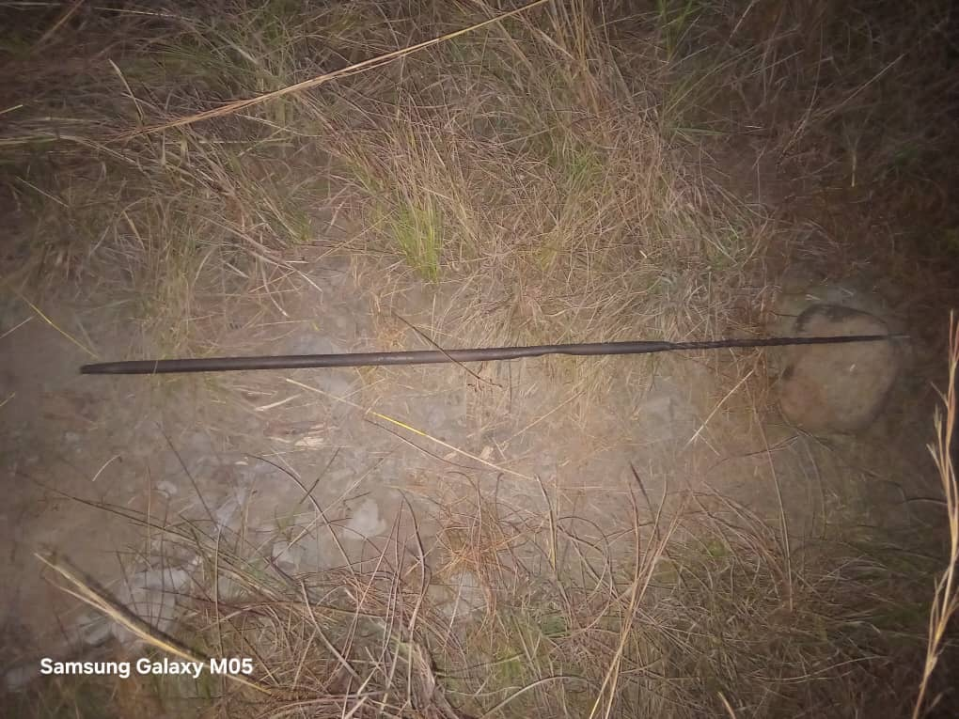  Metal spearing rod, part of the recovered kit.
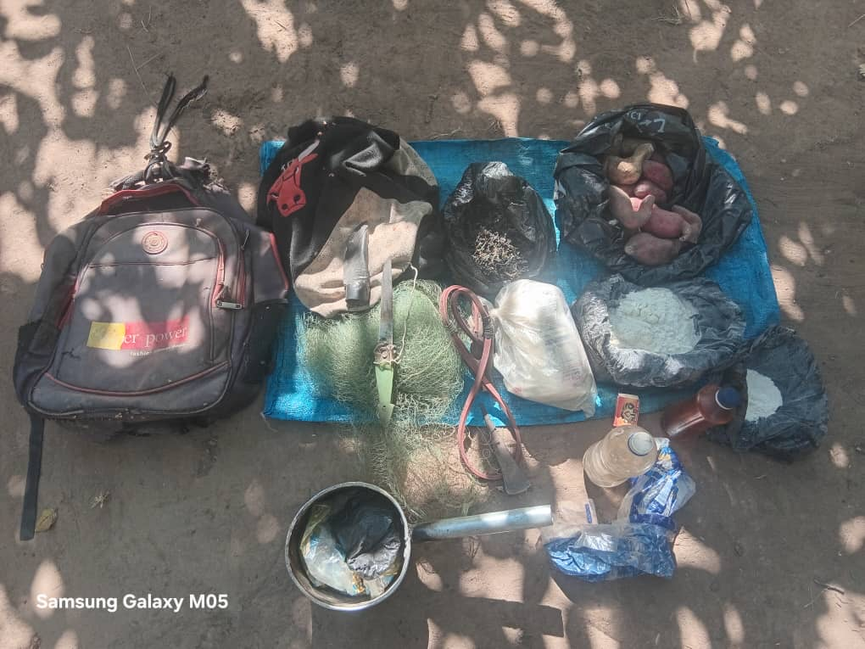
Recovered gear: bags, mealie meal, snaring material, and tools — equipment for an extended stay in the bush.
A spear built for close-range kills. Sacks of food. Snaring material. A backpack meant for more than a day trip. This wasn't a group testing their luck for an afternoon — it was a hunting party equipped to work the bush for an extended stretch. Losing that kit sets them back, even without an arrest: replacing a spear, wire, and food supplies takes time and money they don't currently have.
The four men are still out there. But for now, they're on foot, without their gear, and without the dogs that gave them their edge.

GWAYI PAINTED DOG CONSERVATION AREA

Caught Mid-Chase at Hangano Ranch
On 20 June, a routine snare sweep near Gwayi Farm turned into an arrest. Rangers out of JB Base spotted three dogs mid-chase, running down a common duiker through the bush at Shangani River, Hangano Ranch. Moments later, two men came into view behind them, one gripping an axe.
Both suspects — Osama, 18, and Bhutina, 18, both from Lubimbi village — were apprehended on the spot.
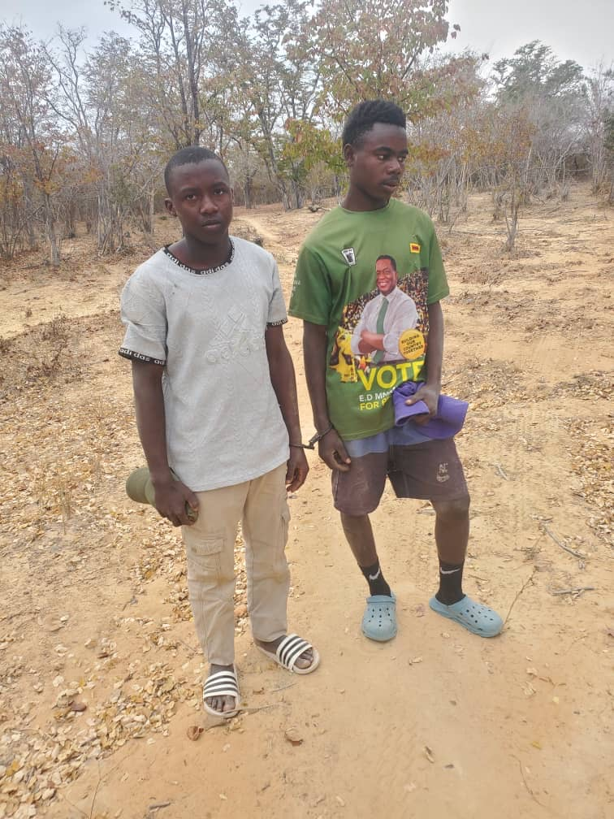  Osama, 18, and Bhutina, 18, apprehended at Hangano Ranch. | Both men were caught running behind their dogs mid-chase, one carrying an axe.
The three dogs, animals trained specifically to run game to exhaustion for the kill, were destroyed at the scene.
  Two of the dogs used in the hunt. |   A third dog, at close range.
Osama and Bhutina were transported to Gwayi Police Post, logged under RRB 6498214.
What makes this case notable isn't just the arrest. Over the course of a single 10-hour patrol shift, the same team removed 25 bird snares along the corridor between Shangani River and the eastern edge of Hangano Ranch — a mix of freshly set nylon lines and older, weathered steel wire, spread across more than a dozen locations. That's not a single opportunistic poacher's work; it's a maintained snare line, likely re-set over weeks.
Rangers on patrol: Sgt Moyo, Prince Ngwenya, Washington Mleya, Lorence Dube, Purge Muleya

BIG DAM, KARNABLOCK, GWAYI PDC

A Warning Shot, One Escape
On 29 June at Big Dam, Karnablock, rangers observed two men in the act of setting snares for guinea fowl and common duiker. One fled into the surrounding terrain and got away. The other — Aleck, from Chibhyu village, under Chief Kavula — was apprehended after a warning shot was fired.
The Anti-Poaching Unit team with Aleck and the recovered snares and tools. | Recovered from the arrest:  - 6 wire snares  - 24 guinea fowl snares  - 1 axe  - 1 knife  - 10 twists of marijuana
Thirty snares and the tools to keep setting more — carried by one person, on one outing. Aleck was handed over to Gwayi Police Station.
The man who escaped is still out there, and so, in all likelihood, is whatever line of snares he was working before rangers arrived.
Note: the shotgun visible in this photo is standard Anti-Poaching Unit issue, carried by the ranger team on patrol — it was not a recovery from the suspect.

GET INVOLVED

Is Your Property Ready for Peak Poaching Season?
Five incidents, four outcomes: a road accident logged and handed off, a hunting party that slipped away but lost its equipment and a dog, an arrest made mid-chase, and a snare-layer stopped before he could set his next line. None of this happened by chance. It came from trained rangers who know the terrain, sustained patrol schedules that don't let up, and the patience to sit on an ambush for hours when the intelligence says it's worth it.
Winter isn't easing up. The bush is dry, the moon is full, visibility is wide open, and idle hands in neighboring villages are looking for income wherever they can find it. If your property borders communal land, has had gaps in patrol coverage, or simply doesn't have enough boots on the ground right now, this is the season those gaps get found — and exploited.
GRTTS (Game Ranger and Tracker Training Specialist) deploys specially trained, experienced rangers to protected areas, private conservancies, and community reserves across Zimbabwe that need reinforcement through the high-risk winter months. Our teams bring the same intelligence-led, patrol-heavy approach behind every incident in this report — built to protect your wildlife until the rains bring the usual seasonal relief.
If your conservancy needs additional ranger coverage this season, get in touch with GRTTS today.
[CONTACT DETAILS PLACEHOLDER — email / phone / website to be inserted]
A note on this report: Suspect names are given as first name and age only, in line with standard reporting practice ahead of any conviction. Graphic imagery has been blurred for this publication.

